1.0 PURPOSE

To outline management policy to determine and select opportunities for improvement and implement any necessary actions to meet customer requirements and enhance customer satisfaction

2.0 SCOPE

QMS established at NIHVA Technologies

DETAILS

  - NIHVA has established process to select improvement opportunities and implement actions to meet and enhance customer satisfaction. These opportunities include-
    - Improving products and services to meet requirements as well as to address future needs and expectations
    - Correcting, preventing or reducing undesired effects
    - Improving the performance and effectiveness of the QMS
    - Improvements can include correction, corrective action, continual improvement, innovation, breakthrough change and re-organization

  - Nonconformity and corrective action

    - Procedure is established to handle nonconformities observed in product, process or system. Corrective actions are taken appropriate to the effects of nonconformities observed. Corrective action is not necessarily required for every occurrence of a non-conformance; it is based on periodic analysis of patterns of non-conformance.
    - Procedure is established to react to the nonconformity by taking action to control and correct it and / or by dealing with the consequences.
    - Procedure is established to evaluate need for action to eliminate the cause(s) of identified nonconformities in order to prevent recurrence. It includes

      - Review and analyze nonconformities
      - Determining the causes of nonconformities
      - Determining if similar nonconformities exist or could potentially occur
      - Implement any action needed
      - Reviewing the effectiveness of corrective action taken
      - Update risks and opportunities determined during planning, if necessary
      - Make changes to the QMS, if necessary
      - Documented information as evidence of the nature of the nonconformities and any subsequent action taken, and the results of any corrective action.

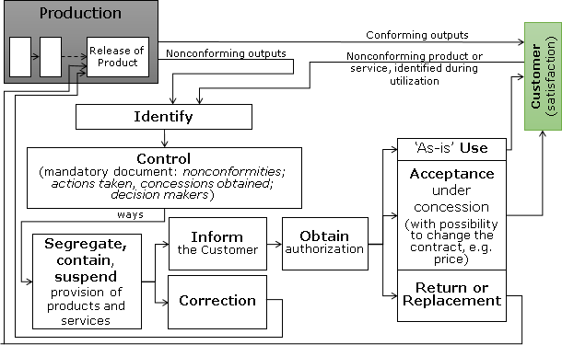

  - Continual Improvement

NIHVA Technologies initiates actions to continually improve the suitability, adequacy and effectiveness of the QMS. Continual improvement techniques and processes are applied to areas of the business that have an impact on the quality of our products and services. We analyze and take necessary actions on results of improvement projects as well as from the Management Review outputs. The implementation of the “Process Approach” including the PDCA Cycle provides verifications that our QMS is robust, and the achievement of effective process performance.

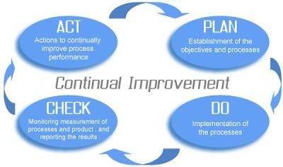
  - Related Documents

QSP-08-001 Control of Nonconformance’s | QSP-09-002 Management Review
QSP-09-001 Internal Audit | QSP-10-001 Corrective Action
QSP-09-002 Management Review | QSP-10-002 5S Lean Practice
QSP-09-004 Analysis and Evaluation of Data & Info. | QSP-10-003 Continual Improvement

